Day, Date, Month, Year
The Hon. FIRST NAME LAST NAME, MP
Member for XXXXXXX
OFFICE ADDRESS

RE: I SUPPORT NATURAL MEDICINE AND I VOTE
Dear [Mr/s LAST NAME],
I am writing to you to express my deep concern about the recent announcement by the Australian Government regarding the removal of the private health insurance rebate for certain natural therapies from 1 April 2019.
Ref: http://www.smh.com.au/federal-politics/political-news/health-fund-premiums-to-be-reined-in-under-sweeping-turnbull-government-changes-20171012-gyzdtq.html
I assure you that if you support the removal of funding for natural medicine via the private health funds, you and your party will not get my vote in the next election!
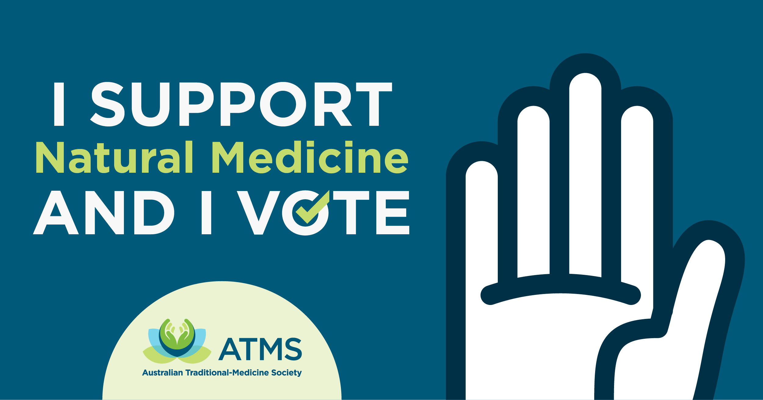
This issue is important to me for three major reasons:
Firstly, by removing this rebate from private health funds, you are limiting my right to choose the type of health care I wish to receive.
I pay and choose my private health insurance premiums with extras cover to access rebates on natural medicine and I do not want this option to be removed.
Secondly, the natural medicine industry is built on 25,000 small businesses which contribute $4.2bn to the Australia economy. Thousands more tax-payers are employed in the wider education, manufacturing, wholesale, supply and retail network. If the proposal goes ahead demand will be affected, your local natural medicine small business practitioners could lose business or even shut-down, which would impact local jobs.
Thirdly, natural medicine is a preventative LONG-TERM strategy that will reduce the financial burden to the Australian economy.
I strongly believe that natural medicine is crucial to the preventative health strategy of Australia and will significantly reduce the burden on the public health system especially as our population gets older and larger. Rather than opting for more expensive medical procedures up front, planned wellness strategies, which natural medicine practitioners espouse, can potentially save the healthcare system on hospital and medical costs in the long run.
As a member, practitioner or clinic owner PLEASE ADD a personalised section to the letter stating your accredited modality of natural medicine practice and all the Associations you belong to. Please also add your opinion on the impact this could have on your personally, your business and as an employed citizen of Australia.
I urge you to reconsider your support of the proposed changes because I support natural medicine and I vote.
Yours sincerely,
[Name, Surname, Email Address, Local Area of Residence]

If you are sending to your MP by email please cc: president@atms.com.au so we can collect and utilise your stories in our communication with health funds and Government directly.
Alternatively, if you are sending by post or in person, please send a copy of your letter to: PO Box 1027, Meadowbank NSW 2114

IBIS World, Alternative Health Therapies in Australia, August 2012.

